**Progress report 14**

Tawab Karim

|  |  |
| --- | --- |
| Date | 17/12/2019 |
| Subject | Website |
| Project Term |  |

# Outcomes of the last meeting (03/12/2019)

* Some remarks about the design of the website from Carlas. The microscopes should be divided up into different categories and you should be able to select a microscope and see the software which accompanies this type of microscope.
* Switched to wordpress in order to keep it easy for others to change/work with the website.
* Alex is busy with the windmill project, I will thus assemble the laserbox myself.

# Results during the last week(s)

* Meeting with Jan, they have started with Batch-4, the delivery date has been pushed to after January though. (Changed in production list)
* Drawings made for Batch 5 and scheduled a meeting with Jan and Nisse in order to discuss this batch.
* Designed mount for the TI DMD

# Other business

* There will be a lot of changes within the production department. New employees and changes in production line. Jan has mentioned that he might retire within the next 4 years even. He’ll keep me updated about this, while this affects us aswell.
* Last week I was sick, I couldn’t do much work… Im thus 1 week behind om my schedule, I will try to correct this as soon as possible.

# Plans for next week(s)

* Finalize the website in wordpress
* Start with the building of the Laserbox
* The week after I will start with the design of the new light sheet module.

# Schedule current and next week

## This week

* Monday 0900-1500
* Wednesday 1100-1800

## Next Week

* Monday 1000-1800
* Friday 1000-1800

|  |  |  |  |  |
| --- | --- | --- | --- | --- |
| Project | Figure | Current Components | Needed Components | Earliest Due Date |
| DMD-Setup | LINK |  |  |  |
| TIRF-Setup | LINK | 1,2,3,4,6,7,8,10 | 5,9 | 30/09/2019 |
| LS-Module | LINK |  |  |  |

## 

|  |  |  |  |  |  |
| --- | --- | --- | --- | --- | --- |
| Figure no. | Component code | Component Name | Amount in Inventory | Amount in production | Production due date |
| 1 | CR001-A | Microscope Tower | 1 | 2 | 30/09/2019 |
| 2 | CR002-A | EM Plate | 1 | 2 | 30/09/2019 |
| 3 | CR003-A | FilterPlate | 1 | 2 | 30/09/2019 |
| 4 | CR004-A | CoverPlate V2 P1 | 1 | 2 | 30/09/2019 |
| 5 | CR005-A | CoverPlate V2 P2 | 0 | 3 | 30/09/2019 |
| 6 | CR006-A | BottomPlate | 1 | 2 | 30/09/2019 |
| 7 | CR007-A | Stage Mount | 3 | 0 | - |
| 8 | CR008-A | Stage Plate | 3 | 0 | - |
| 9 | CR009-A | Tube Lens Mount | 0 | 1 | 18/10/2019 |
| 10 | PP001-A | CameraMount | 2 | 0 | - |
| 11 | CR008-B | Stage Plate | 0 | 1 | 18/10/2019 |
| 12 | CR010-A | StageThorlabsAdapter-A | 0 | 1 | 18/10/2019 |
| 13 | CR011-A | StageThorlabsAdapter-B | 0 | 1 | 18/10/2019 |
| 14 | CR012-A | SpacerBlockStage | 0 | 1 | 18/10/2019 |
| 15 | CR013-A | FilterPlateStraight | 0 | 1 | 18/10/2019 |
| 16 | CR020-A | PanelLaserBox1 | 0 | 1 | 04/10/2019 |
| 17 | CR021-A | PanelLaserBox2 | 0 | 1 | 04/10/2019 |
| 18 | CR022-A | PanelLaserBox3 | 0 | 1 | 04/10/2019 |
| 19 | CR023-A | PanelLaserBox4 | 0 | 1 | 04/10/2019 |
| 20 | CR024-A | PanelLaserBox5 | 0 | 1 | 04/10/2019 |
| 21 | CR025-A | PanelLaserBox6 | 0 | 1 | 04/10/2019 |
| 22 | CR026-A | PanelLaserBox7 | 0 | 1 | 04/10/2019 |
| 23 | CR027-A | PanelLaserBox8 | 0 | 1 | 04/10/2019 |
| 24 | CR028-A | PanelLaserBox9 | 0 | 1 | 04/10/2019 |
| 25 | CR029-A | PanelLaserBox1D | 0 | 1 | 04/10/2019 |
| 26 | CR030-A | PanelLaserBox4D | 0 | 1 | 04/10/2019 |
| 27 | CR014-A | OuterBlock1 | 0 | 1 | 31/01/2020 |
| 28 | CR015-A | OuterBlock2 | 0 | 1 | 31/01/2020 |
| 29 | CR016-A | InnerBlock | 0 | 1 | 31/01/2020 |
| 30 | CR017-A | PolerazationConnector | 0 | 1 | 31/01/2020 |
| 31 | CR018-A | PolerazationSelector | 0 | 1 | 31/01/2020 |
| 32 | CR031-A | BackPlateMirror | 0 | 0 | - |
| 33 | CR032-A | MirrorRotMount | 0 | 0 | - |
| 34 | CR033-A | HoldPlate | 0 | 0 | - |
| 35 | CR034-A | Mounting | 0 | 0 | - |
| 36 | CR035-A | SidePlateConnector | 0 | 0 | - |
| 37 | CR036-A | SidePlateB | 0 | 0 | - |
| 38 | CR037-A | SidePlates | 0 | 0 | - |
| 39 | CR038-A | NemaMount | 0 | 0 | - |
| 40 | CR039-A | HaltePlatte | 0 | 2 | 31/01/2020 |
| 41 | CR040-A | Anschraubplatte | 0 | 2 | 31/01/2020 |
| 42 | CR041-A | Kugelhalter2 | 0 | 4 | 31/01/2020 |
| 43 | CR042-A | Kugelhalter | 0 | 2 | 31/01/2020 |
| 44 | CR043-A | Kugelhalter3 | 0 | 2 | 31/01/2020 |
| 45 | CR044-A | BasePlateStage | 0 | 1 | 10/01/2020 |
| 46 | CR045-A | MountingPlate | 0 | 2 | 10/01/2019 |
| 47 | CR046-A | StepConnectPlate | 0 | 1 | 10/01/2019 |
| 48 | CR047-A | BackPlateMirror | 0 | 1 | 10/01/2019 |
| 49 | CR048-A | HoldPlate | 0 | 1 | 10/01/2019 |
| 50 | CR049-A | MirrorRotMount | 0 | 1 | 10/01/2019 |
| 51 | CR050-A | Mounting | 0 | 1 | 10/01/2019 |
| 52 |  |  |  |  |  |
| 53 |  |  |  |  |  |
| 54 |  |  |  |  |  |
| 55 |  |  |  |  |  |
|  |  |  |  |  |  |
|  |  |  |  |  |  |
|  |  |  |  |  |  |
|  |  |  |  |  |  |
|  |  |  |  |  |  |
|  |  |  |  |  |  |
|  |  |  |  |  |  |
|  |  |  |  |  |  |
|  |  |  |  |  |  |
|  |  |  |  |  |  |
|  |  |  |  |  |  |

## Project figures

|  |
| --- |
| DMD-Setup |
|  |
| TIRF-Setup |
|  |
| LS-module |
| -image not yet made- |

## Component figures

|  |  |
| --- | --- |
| Figure 1 -- CR001-A | Figure 2 – CR002-A |
|  |  |
| Figure 3 – CR003-A | Figure 4 – CR004-A |
|  |  |
| Figure 5 – CR005-A | Figure 6 – CR006-A |
|  |  |
| Figure 7 – CR007-A | Figure 8 – CR008-A |
|  |  |
| Figure 9 – CR009-A | Figure 10 – PP001-A |
|  |  |
| Figure 13 – CR008-B | Figure 12 – CR010-A |
|  |  |
| Figure 13 – CR011-A | Figure 14 – CR012-A |
|  |  |
| Figure 15 – CR013-A | Figure 16 – CR020-A |
|  |  |
| Figure 17 – CR021-A | Figure 18 – CR022-A |
|  |  |
| Figure 19 – CR023-A | Figure 20 – CR024-A |
|  |  |
| Figure 21 – CR025-A | Figure 22 – CR026-A |
|  |  |
| Figure 23 – CR027-A | Figure 24 – CR028-A |
|  |  |
| Figure 25 – CR029-A | Figure 26 – CR030-A |
|  |  |
| Figure 27 – CR014-A | Figure 28 – CR015-A |
|  |  |
| Figure 29 – CR016-A | Figure 30 – CR017-A |
|  |  |
| Figure 31 – CR018-A | Figure 32 – CR031-A |
|  |  |
| Figure 33 – CR032-A | Figure 34 – CR033-A |
|  |  |
| Figure 35 – CR034-A | Figure 36 – CR035-A |
|  |  |
| Figure 37 – CR036-A | Figure 38 – CR037-A |
|  |  |
| Figure 39 – CR038-A | Figure 40 – CR039-A |
|  |  |
| Figure 41 – CR040-A | Figure 42 – CR041-A |
|  |  |
| Figure 43 – CR042-A | Figure 44 – CR043-A |
|  |  |
|  |  |
|  |  |
|  |  |
|  |  |
|  |  |
|  |  |

# Appendix

### 

### 

### 

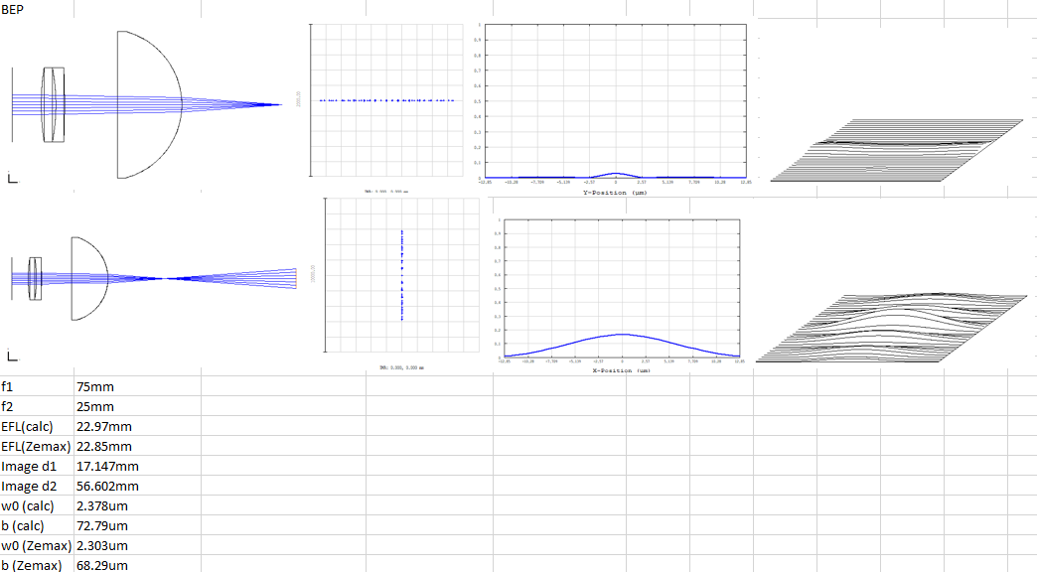

This is a summary of the simulations done with the components that the BEP group used. Looking at both focal distances of the light sheet. Hand calculations roughly match the simulations done in ZEMAX. The top row shows the first focal line of the light sheet and the second row shows the second focal line of the light sheet. From left to right, the setup, the dot diagram, the PSF cross section and the 3D PSF are shown.

This system has been compared to the inverted BEP setup, while the cilindrical lens is recommended to put the other way around. Results are shown below.

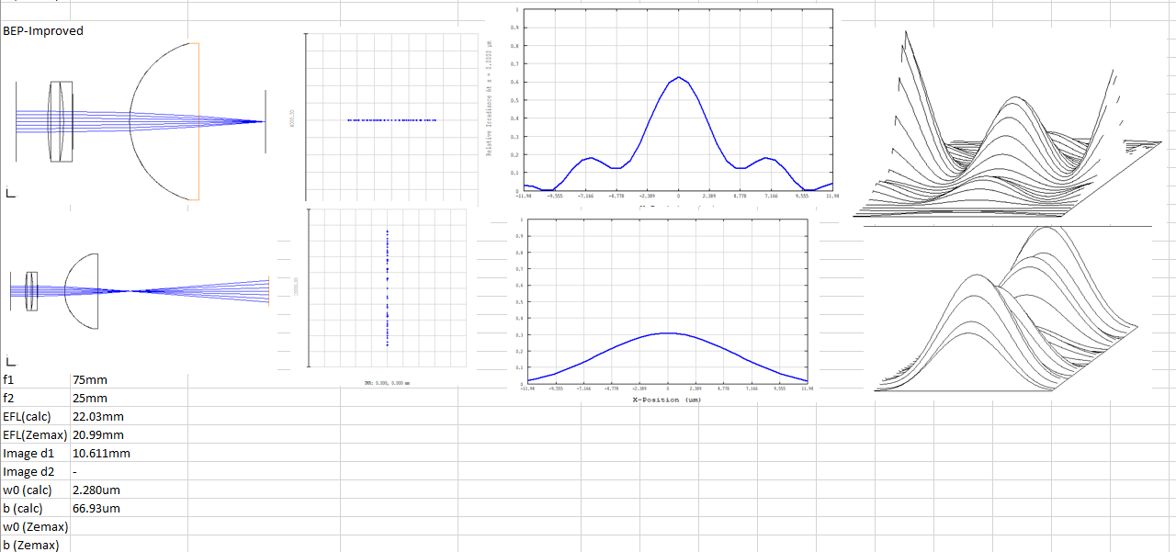

These two are compared to the AIM light sheet.

